1. Briefly describe the MVC pattern.

A pattern in software development that helps you separate different parts of an app into easily testable aspects of the app.

1. Which part of MVC handles each of the following?

User Interface logic – View

Input logic – Controller

Business logic – Model

1. What is meant by an HTTP endpoint, and give an example of one from your favorite website?

An HTTP endpoint is the attachment at the end of a url to redirect to that method .

1. Given this website address, <http://catalog.indianhills.edu/index.php?catoid=44>, answer the following:

What is the protocol? HTTP

What is the target URI (endpoint?) index

What is the parameter? Catoid=44

1. What is the default routing logic used by MVC?

/[Controller]/[ActionName]/[Parameters]

1. Where is the routing format actually specifed?

Startup.cs

1. What is the purpose of HtmlEncoder.Default.Encode?

It protects the app from malicious attacks mainly javascript being inserted

1. Using the revised Welcome method as an example, add a new method to the Home Controller called CalcSum. This method should have two integer parameters, and should use optional parameter values of your choice. The method should return the sum of the two numbers back to the brower, such as Sum is xx. Screen shot the code AND of your browser showing it works.

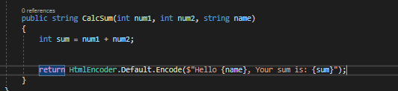

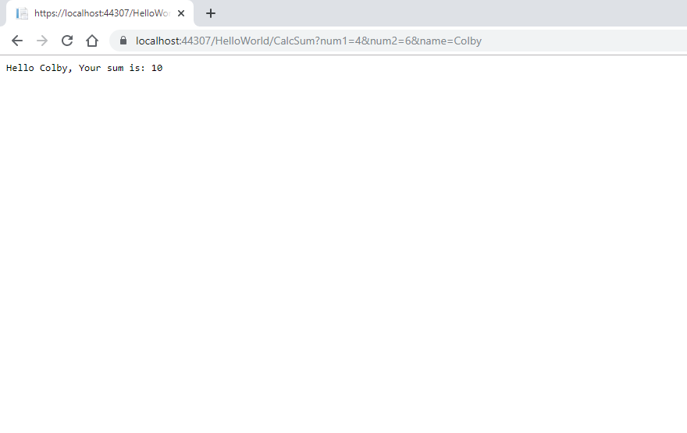

1. Do your URL parameters have to be passed in the same order as the method defines them?

No

1. What allows the named parameters in the URL to map to the corresponding method parameters?

The endpoints.MapControllerRoute contained in the Configure method in Startup.cs